Rhythm Simulator
Project Report

Name: Kayla Isabelle Limaran
Course: Algorithm and Programming
Institution: BINUS International

- Programming Specification
- Program Overview
The Rhythm Simulator is a program that simulates a rhythm game’s patterns to practice and understand the fundamentals of rhythm games. Users can use the app together with another person and essentially play the game as a medium to practice with.

- Objectives
- To understand how to play rhythm games or practice with it
- To use functions, dictionaries, and if statements to create the program
- To use libraries like Pygame and use their capabilities for the game
- To learn how to make custom art for the game
- To learn how rhythm games function and work

- Scope
- Using timing to and speed to detect when a note is hit
- Displays when a note has been hit
- Uses arrow keys and ‘WASD’ keys to hit notes

- Stucture
main.py = The main loop and center of the functions
level1.py = The functions to create the notes
assets.py = Contains all the images that are used for the program

- Evidence of Program
Screenshots:
- Main Game
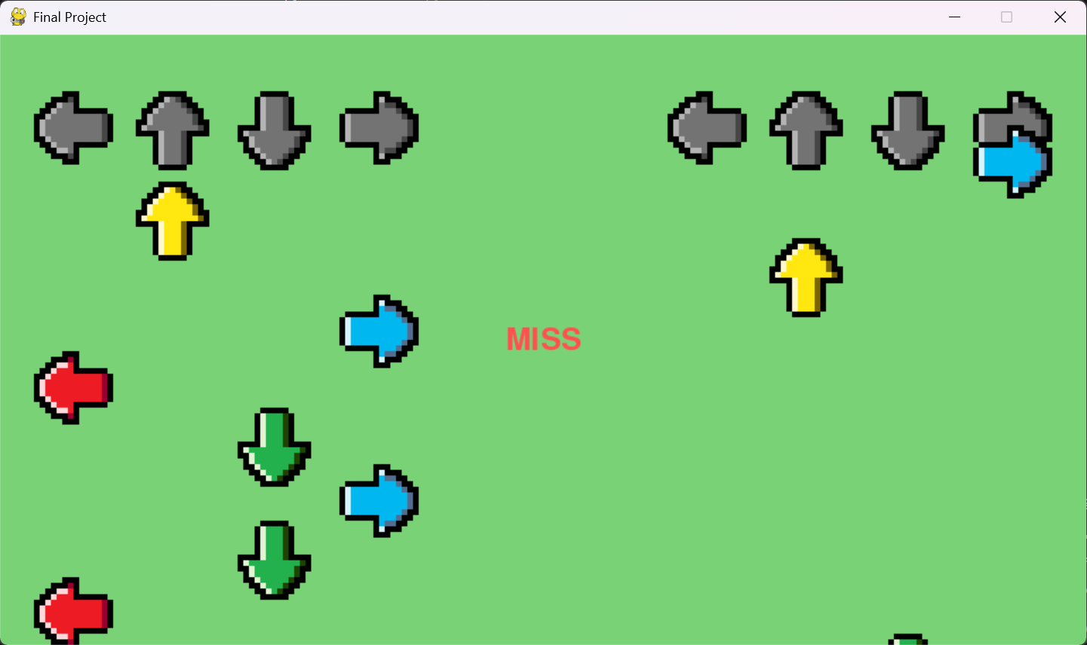

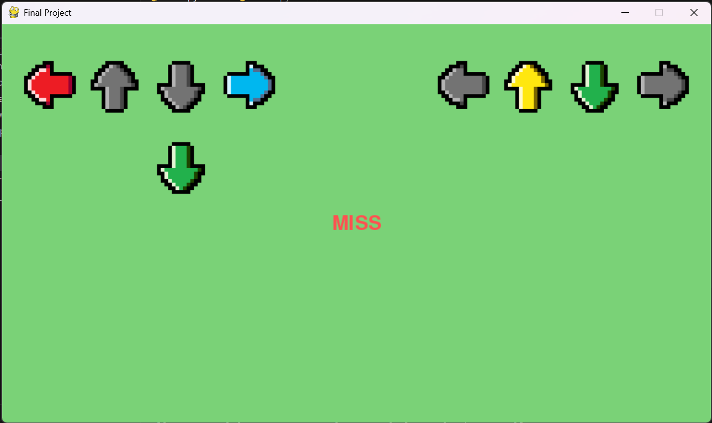
- Pressed Keys

- Reflection
There were many challenges in the making of my project. Some of which include the timing, key detection, and placement. However, I was able to quickly learn and implement them properly into my program.

For future improvements, I should add a counting system, actual songs with rhythms that follow the beats, and a background and sprites.

- Statements on The Use of Artificial Intelligence
For this project, AI was used for solely debugging and learning. It was used to help create basic skeletons on how the program should be structured, fixing and finding issues within the code, and developing.

Some examples for this include fixing bugs and issues on why the placement were wrong and proper structuring so the code works in their respective orders. I had also used it to help explain which functions I should be using to get better results.

Prompt examples:
- I would like to make a sort of rhythm game that can be played on the same device with 2 players, one uses WASD keys and the other plays with the arrow keys. I don’t want you to make the code for me, I want you to help me step by step but I must write and learn the code myself so that I can learn from it.
- How do I get the arrows to detect every time I press an arrow key?
- Please help find the issue with my code, it does not seem to be working

- Conclusion
This project is a program that simulates rhythm games and has been developed using certain principles and had many learning curves. It was created with experimentation and improvement in mind and can be further improved in the future.

- Appendix

